# Introduction

# Introduction

UIFlow is the Integrated Development Environment (IDE) created by M5Stack and is the third incarnation of the programming environment.

In various documents references are made to M5Cloud and Moments, these are the two previous versions and are no longer available.

UIFlow contains two environments. Blocky, the default environment is a basic programming aimed at the young and beginners to programming. Micropython, the second environment is a text based environment that is at the core of all the firmware and functions of blocky. Once a programmer has grown beyond blocky, they can use the Micropython environment to dig deeper in to the functions and develop new blocks for Blocky or program the M5Stacks and M5Sticks at a lower level.

Blocks in UIFlow can be separated into three groups, actions, loops and values.

Actions are the blocks that contain command to preform tasks.

Loops are used for code that needs to be repeated.

Values provide numbers that can vary or be defined by the programmer.

I hope that this section will explain what the various blocks available in the UIFlow environment are. In another section I will show examples on how to use the various blocks to make things work.

## M5-Cores

## 

## Core 2

## 

## M5 Stick

## 

## M5 Atoms

## 

## Stick V / Unit V

## 

## Timer Camera

Currently the Thermal Camera does not have support for UIFlow firmware

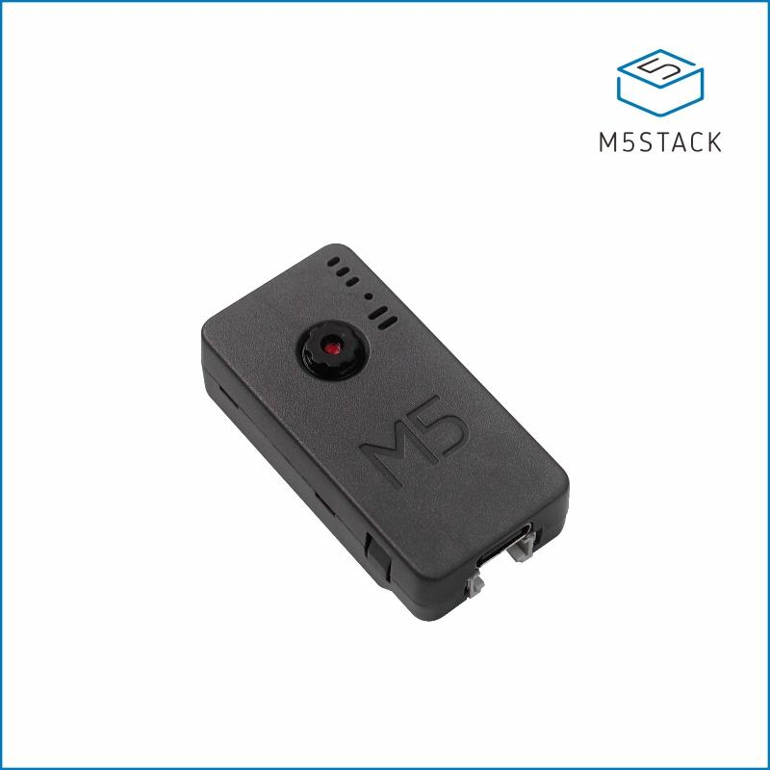.

## M5Electron Burner

The current firmware tool is called the Electron Burner. This version has a new cleaner, easer to navigate layout compared to the previous version and a screen shot can be seen in the following images.

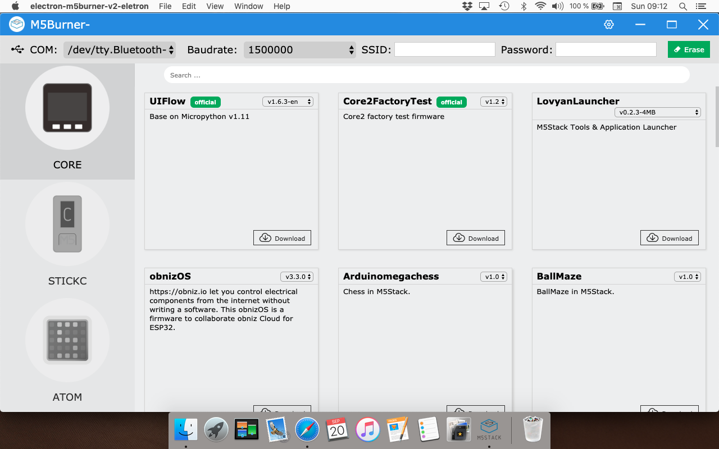

With the new program comes some new setting options. On the left of the new bar we have the familiar Com Port and Baud rate options but now we also have options for pre setting The SSID and password that M5Stack devices will use to connect to the target wifi network.

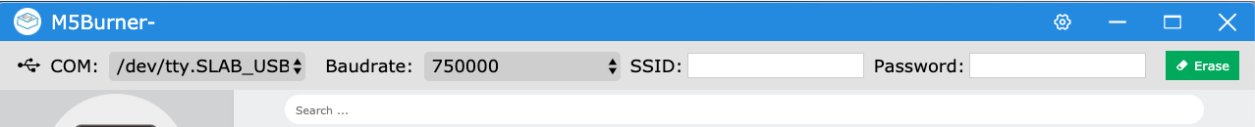

One important note about WIFI SSID and passwords: SSID’s can not contain a space or special characters in the name. If there is a space, or special character then for some reason M5Stack devices will fail to connect to wifi networks.

Pre setting the WIFI SSID and password can save us some setup time but it is not the only way to connect a device to a network. The additional wifi connection methods will be explored after I demonstrate how to install firmware.

## Installing UIFlow Firmware.

With the exception of the SSID and Password box’s, installation of UIFlow firmware hasn’t changed much compared to the previous version.

Before we connect the M5Stack, Stick or Atom to the computer, we first need to download a USB driver that will allow our host computer to talk to our device.

To find the driver we need to visit https://m5stack.com/pages/download and in the software menu on the left, click on download and select the operating system that you are using.

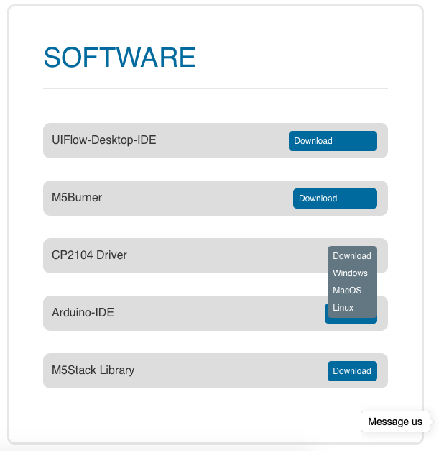

Once downloaded, run the install process. Once the install has finished, shut down the computer, wait a few minutes and then restart the computer. There is an issue with OSX and Windows in that if the shut down is not completed, a built in faulty drive will be loaded resulting in M5Stack devices failing to connect over USB.

Important Note: If after this step, if your computer still does not connect to an M5Stack product, try a good quality USB C Data sync cable as the cheep cables suffer with broken conductors and charge cables sometimes don’t have the data wires.

In the left panel we have images of the M5Stack, Stick and Atom, StickV/UnitV and Timer Camera. Click on the image that matches the device you are using and the main panel will now show you the list of available pre built firmwares. Some firmwares will have multiple revisions available (like UIFlow) which can be chosen by click the drop down list next to the firmware name.

Please note that when selecting the firmware revision, there may also be several versions of that available. In the case of UIFlow on the Core there is a version for the Core, Fire, and Core 2 due to the difference in hardware configurations.

First we select the Com port a M5Stack is connected to. On a Windows computer, the device will be shown as “Com” however, with OSX, BSD and *nix based computers, devices will ofter appear as /dev/tty *** with a different string for different devices.

## For M5Stack Core, Gray, Go, Fire and, Core 2

Click on the Core Icon



Click on UIFlow and then in the dropdown box chose the revision number that ends in “en”.

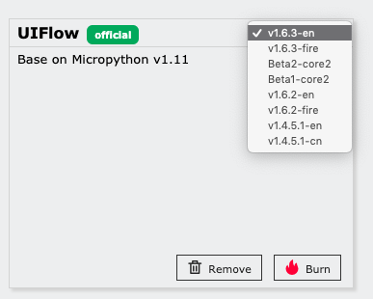

For the Fire chose the revision ending in “Fire” and for the Core 2 chose the revision ending in “Core2” and then click “Download.

Next plug the M5Stack into a USB port and select the Com port.



Leave the Baud rate as is, type in your wifi SSID and Password (not shown for privacy).

Next press the “Erase” Button and the following will appear on screen.

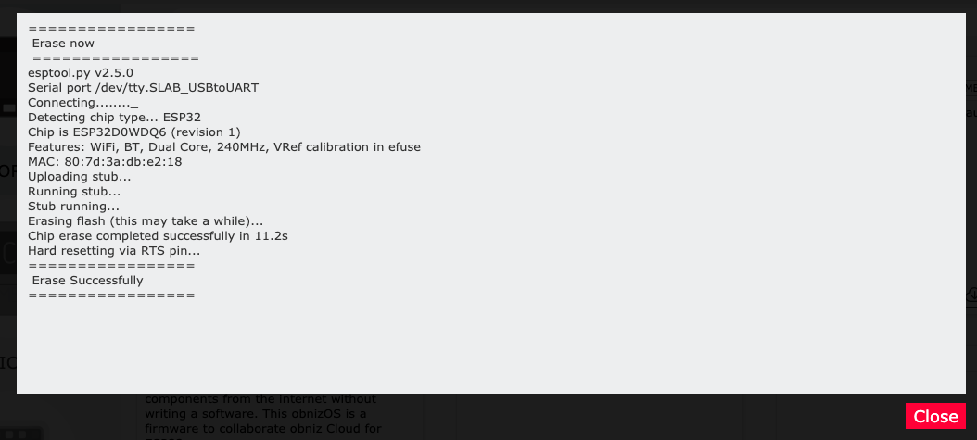

If everything worked, the window will show the “Erase Successfully”. Press the Close button and we can then move on to install the firmware.

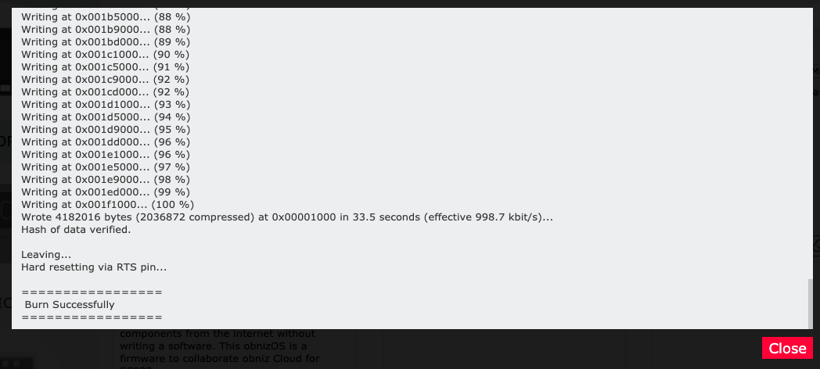

To install the firmware all we need to do is click on the “Burn” button, a new screen will appear and we can wait until you see the message in the following screenshot.

Your device should now restart and show the “Hello” screen of the built in demo.

## The Factory Demo (Excluding Core2).

The factor demo has been designed to show off the functions and sensors included with the M5Go Packs and so will have functions that wont work with the Core (Black).

## To Exit The Factory Demo.

To exit out of the factory demo press the reset/on off button to reset the core and as soon as the screen show up (shown Below) Press the right hand button with “Setup” above it to go into the settings.

In the setting menu the three white button have the following unctions.

Left Button = Move up.

Centre Button = Select/Enter.

Right Button = Move down.

Press the middle button to open the “Switch Mode” menu and you will get the following options.

Internet Mode = For using the online UIFlow.

USB Mode = For using Offline mode also known as the UIFlow Program.

APP Mode = This mode will auto load the last program downloaded to the memory of the core.

Use the right button to move down to “Internet Mode” and press the middle button. The circle next to it should now be filled in and we can now restart the Core by moving down and pressing the middle button once “Reboot >>” is highlighted.

## Wifi Setup

The first time a Core starts up after being set to WIFI Mode, you will be presented with the following screen.

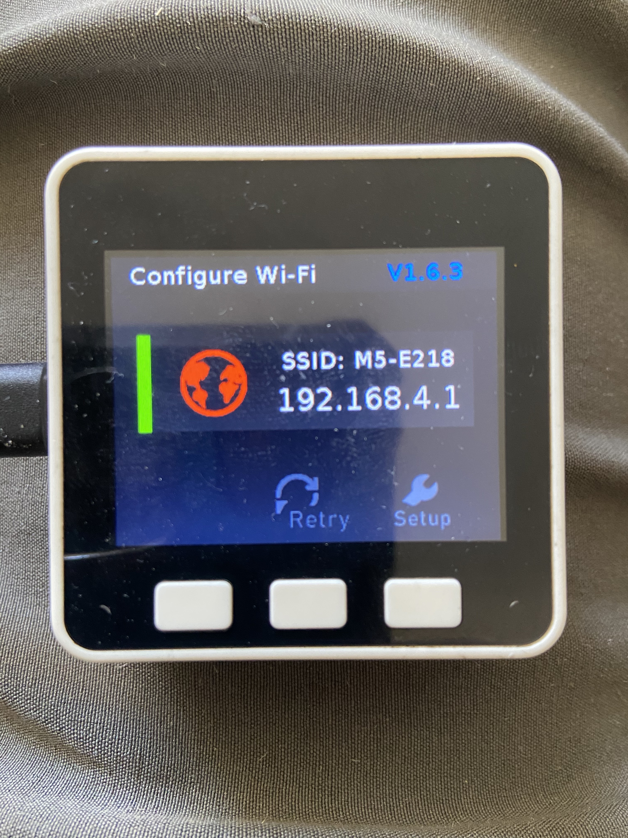

Click on the icon or program you sue to select wifi networks and choose the SSID that matched the SSID shown on the screen of the core. (In this case M5-E218)

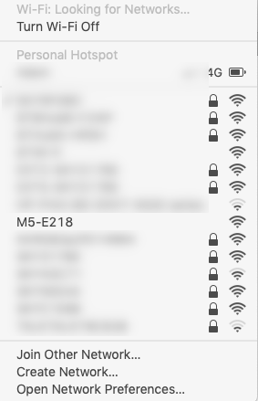

Open a web browser (Explorer. Safari, Firefox or Chrome) and type in 192.168.4. This should load a configuration web page stored on the core which will allow you to set the network SSID and password of the network you wish to have your M5Stack Core connected to.

Select the SSID you want to use (this normally show the closest network), Insert your password and press configure.

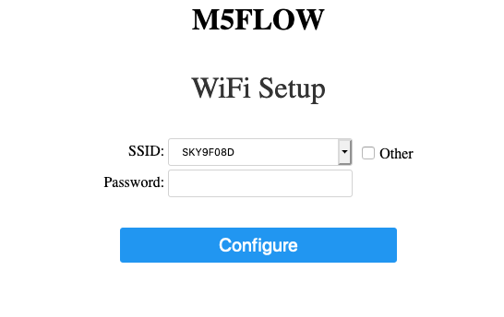

If you entered a valid SSID and password and the core connected, you will be presented with the following in the web browser before the Core restarts and the computer automatically reconnected to the wifi.



## Connecting to UIFlow

Now that we have our M5Stack Core connected to the internet we need to connect the device to the online UIFlow Server. To link our core to the server, we need the API number that is now shown on the screen after each restart.

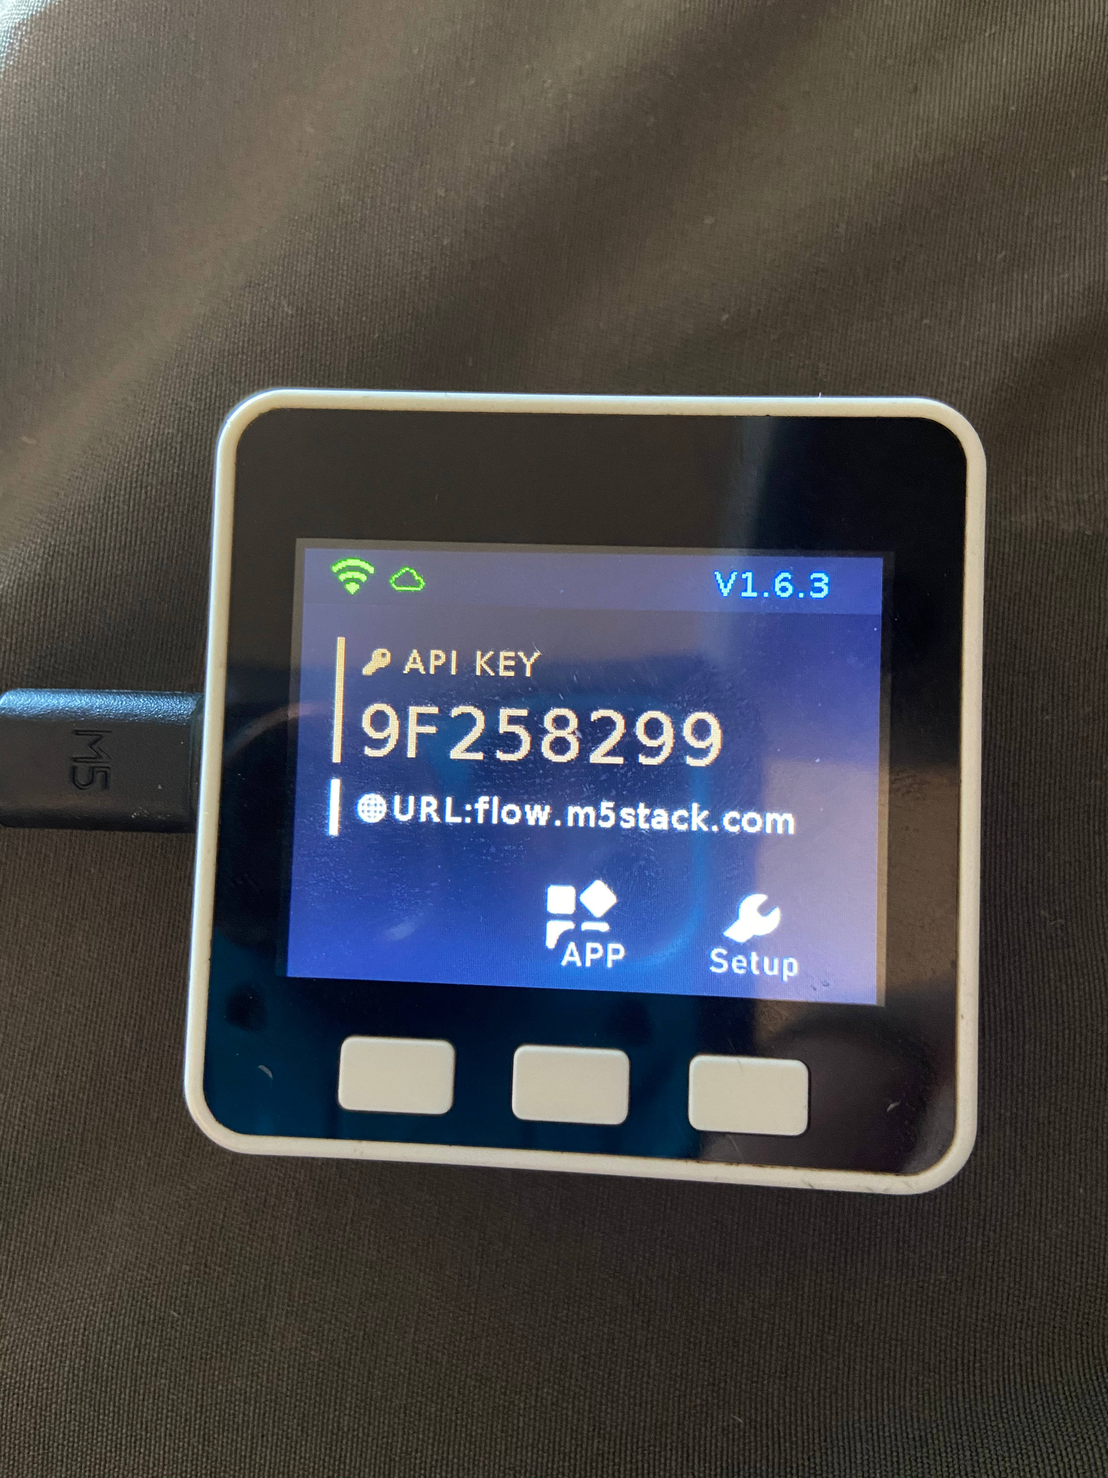

Open a new page in the internet browser and goto <https://flow.m5stack.com/>

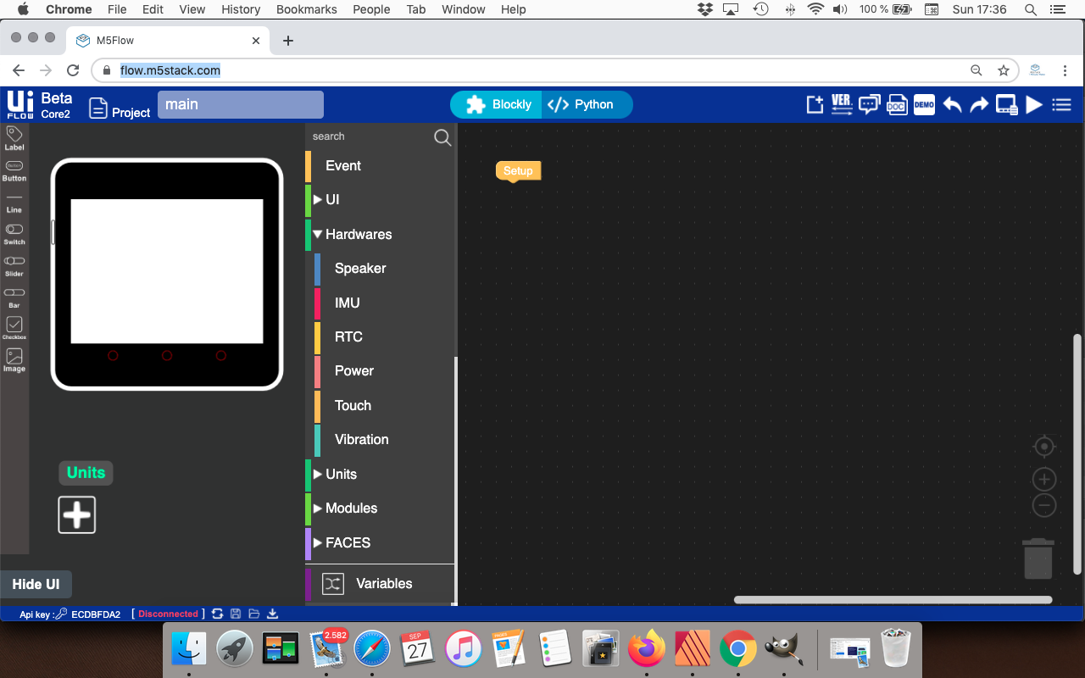

This is UIFlows main screen. Across the top is the title bar which shows the current revision of the UIFlow web server. Next to that is a box that we can use to set our project name. We we want to save the program to a computer the file name will use the project name we specify here.

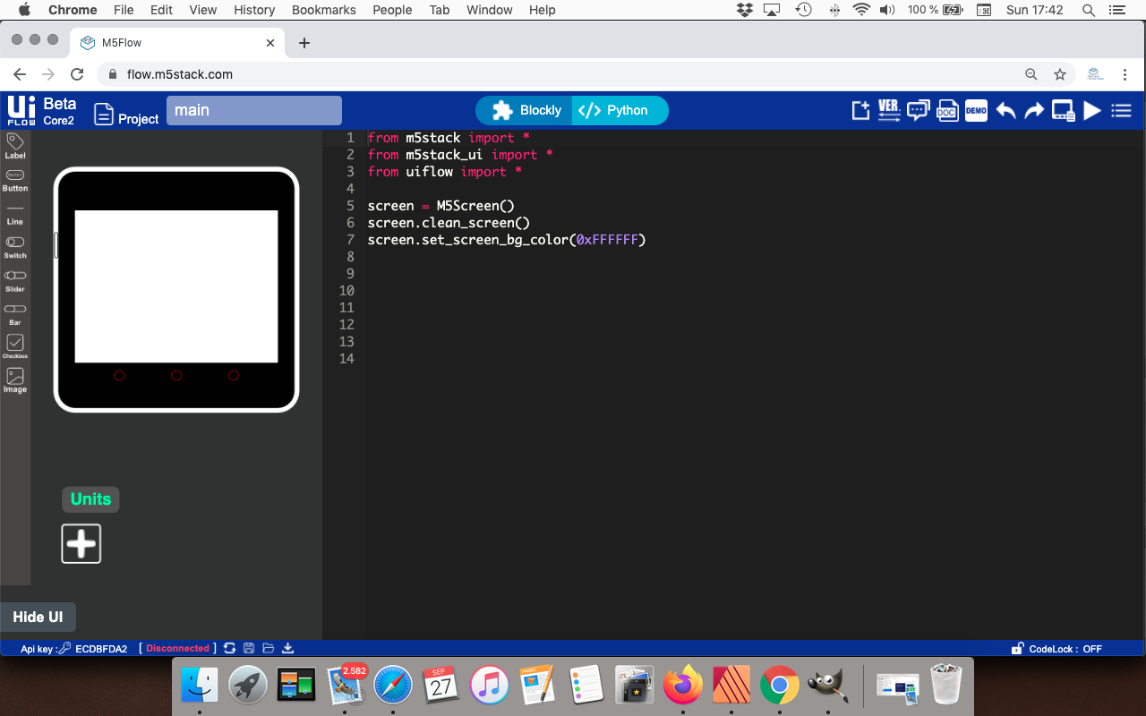

In the middle of the title bar is the two IDE buttons. Blocky is the default IDE shown above, Python takes us to the Code view where we can directly edit and code in Micropython.



On the right of the title bar we have a set of Icons. These icons and their functions are as follows.

• New File - This will clear the current open program ready to start a new program.

• VER - This will allow you to change between the latest stable version and the latest test version.

• Forum - Takes you to the M5Stack Forum.

• DOC - Takes you to the UIFlow online Documentation.

• Demo - Opens a dropdown menu containing available preinstalled demos.

• Undo - Undo a code change.

• Redo - redo a code change.

• Manager - Allows you to add or remove libraries and files to the onboard storage.

• Run - This downloads the program to the the ram to test the program when when you restart the program is lost as it is not premaritally saved.

• Main Menu - Contains UIFlow settings and options to save the code to a computer or to a device perinatally.

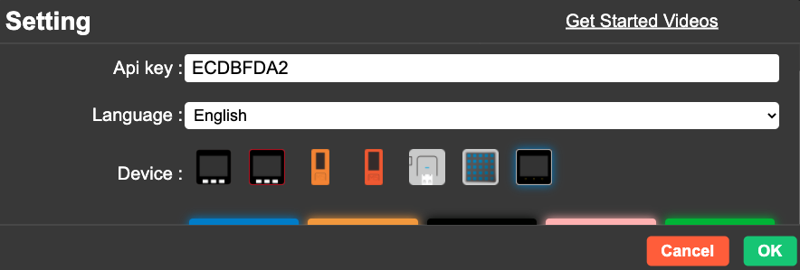

The Settings is where we go to configure UIFlow to connect to and M5Stack, stick or core.

The API Key box is where you type in the number shown of the screen of the M5Stack or Stick.

Language is to set which language you need UIFlow to be in if English is not your language.

Next you click on the icon that represents the device you are connecting to UIFlow. Once these are set you can then click OK to connect UIFlow to your device.

Sometimes UIFlow or the device will not connect to the UIFLow server, this is often down to a bad internet connection or the server being overloaded by users trying to connect online.